AI Use Declaration Form
Course: Introduction to Artificial Intelligence
Lab Title: Lab 1
Student Name: ___Ousmane Boubacar Bako __
Student ID: ________30132027______________________________________________
GitHub Repository Link: ___________________________________________
Date Submitted: _____20/06/2026_____________________________________________

1. AI Use Summary
Question | Student Response
Did you use any AI tool for this lab? | Yes
Estimated percentage of the work influenced by AI | %
Did you attach evidence of AI use where applicable? | Yes

2. Details of AI Use
Complete the table below for each AI tool used. Add more rows where necessary.
Name of AI Tool Used | Purpose for Using the Tool | Prompt or Instruction Given to the Tool | Part(s) of the Work Influenced by the Tool | How I Verified, Edited, or Improved the AI Output
Microsoft Copilot (Chat) | To explain search algorithms (UCS, A, Greedy, Weighted A) | Grid visualization with start and goal | Visual aids for Part B maps | I reviewed all code, ran it in VS Code/Jupyter Notebook, corrected errors where necessary, tested outputs, and ensured I understood the implementation before submission.
 | To learn and understand search algorithms (BFS, DLS) and how they apply to grid navigation | Explain how BFS and DLS work | My understanding of Part A concepts and initial coding | I compared the explanations with the lecture notes, tested the code on sample grids

3. Attachment of AI Output Evidence
Where required, attach evidence of AI use. Tick all that apply. Add more rows where necessary.
Evidence Type | Attached? (Yes, No, N/A) | File Name
AI-generated draft | No
Prompt history | No
Screenshot of AI interaction | Yes | 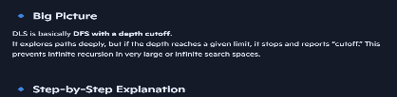
Exported AI conversation
AI-generated code snippet
Revised version showing student input | Yes | 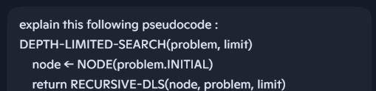

4. Student Declaration
I declare that:
Declaration Statement | Response (Yes/No)
The submitted work is my own work. | Yes
Any use of AI tools has been clearly declared in this form. | Yes
The prompts, instructions, and AI-generated outputs have been disclosed where applicable. | Yes
I reviewed, tested, edited, and improved any AI-generated content before submission. | Yes
My AI usage does not exceed 25% of the entire work. | Yes
I understand that undeclared or excessive AI use may be treated as academic misconduct. | Yes

Student Signature: ______________Ousmane Boubacar Bako___________
Date: _______20/06/2026__________________________

